

Jswponline.com Quick Start Guide

THE TEACHER’S PORTAL
1. Login
Note: Participants who subscribe to only one license will have either a student portal or a teacher portal. Student accounts are able to subm their work to the teacher accounts.  New Assignment – Click here to create or broadcast a sample paragraph with the steps in the writing process.  My Essays – Click here to show the essays you have created.  Student List – Click here to display a list of your students that your IT Department will populate and update as students come and go.  Submitted Assignments – Click here to view the paragraphs and essays that have been submitted by students. When a student submits an assignment.  Change Password – Click here to change your password.  Submit Bug or Feature Request – Click here if something goes awry or if you have a cool idea of how  to improve the program. |   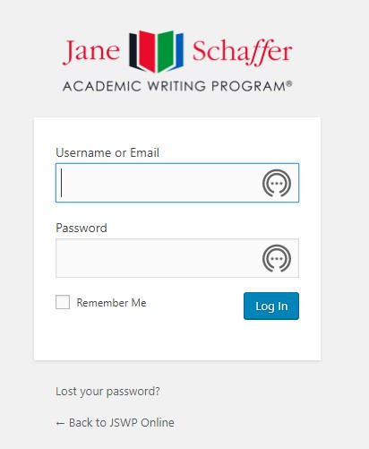  it  This is your Teacher’s Portal.    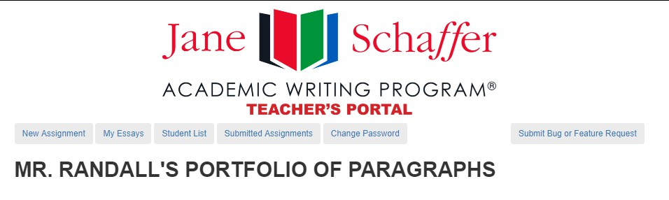  On the Left are Explanations of the Buttons You May Choose.

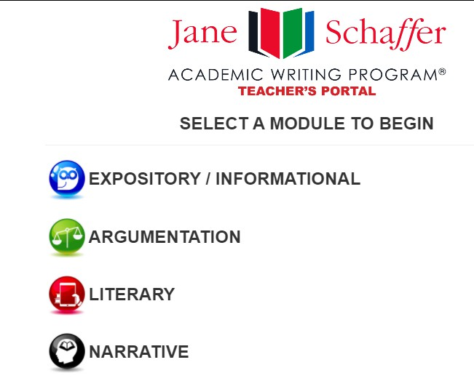


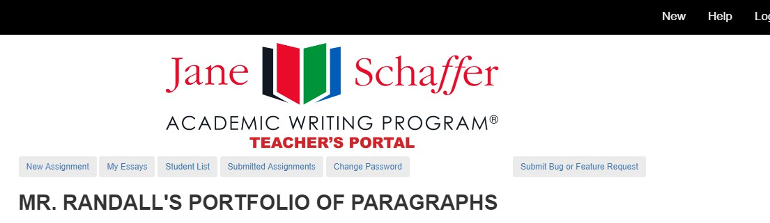
LITERARY / RESPONSE TO LITERATURE
START AN ASSIGNMENT
1. Select the button
that says, “New Click Here Or Click
Assignment” or Here
Click <New>.
- Select the Mode of Discourse:
  - Expository
  - Argumentation
  - Literary
  - Narrative

THE LITERARY PARAGRAPH STUDENT PORTAL


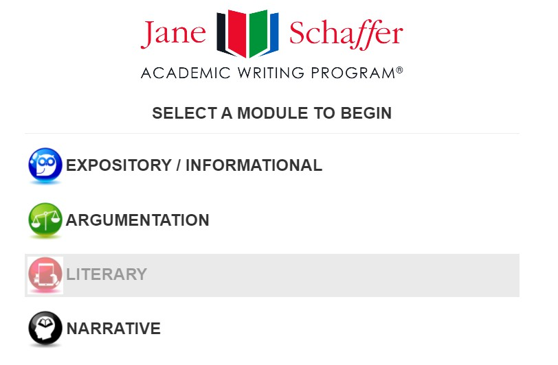


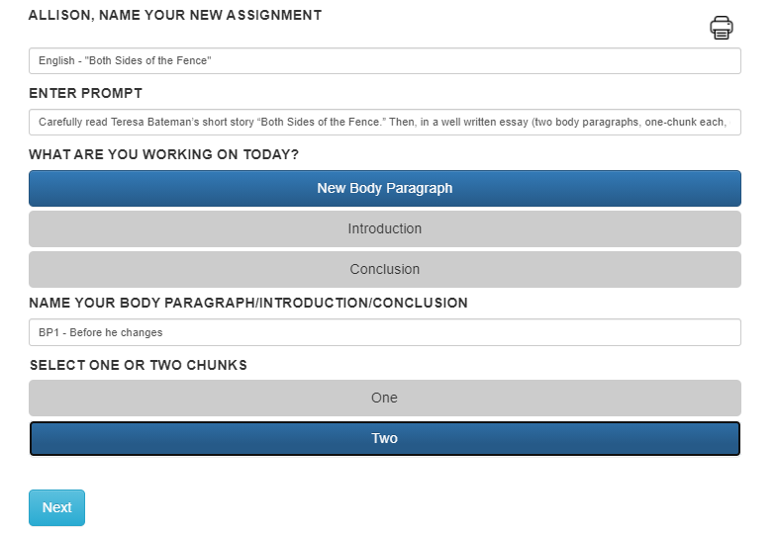
- Name Your Assignment English – “Both Sides of the Fence”
- Enter Prompt: Carefully read Teresa Bateman’s short story “Both Sides of the Fence.” Then, in a well-written essay (two body paragraphs, one- chunk each, (1:2+), discuss how Alberto’s feelings change toward his neighbor.
- Select <New Body Paragraph>.
- Name Your Body Paragraph: BP1 or BP1 – Before he changes.
- Determine One or Two Chunks. Two Chunks.
- Click <Next>.


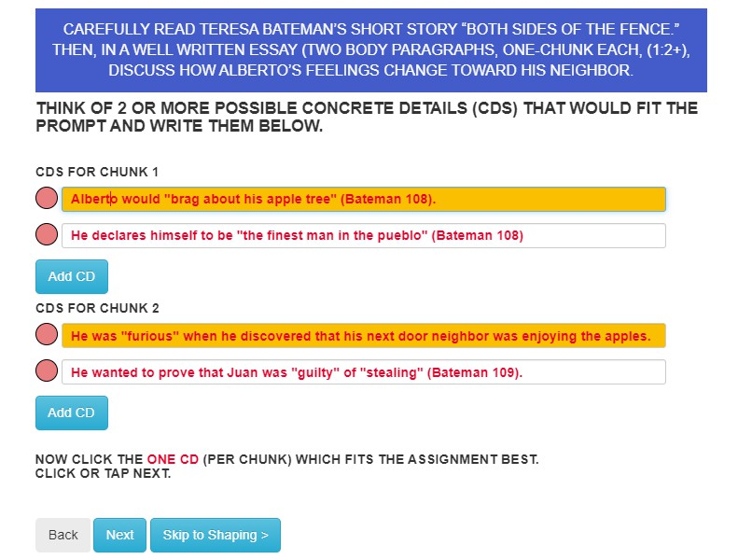
STEP ONE: GATHERING CDS

- LIST AND ADD 3-5
concrete details (CDs) for each chunk.
- HIGHLIGHT the
one CD that you want to use for each chunk.
- Note: Dr. Louis Our next step is going to be the shaping sheet. combined the two CDs for the second chunk into one and chose that one!
- PRINT and/or CLICK <Next>.


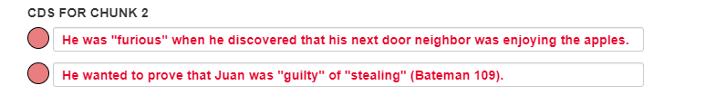

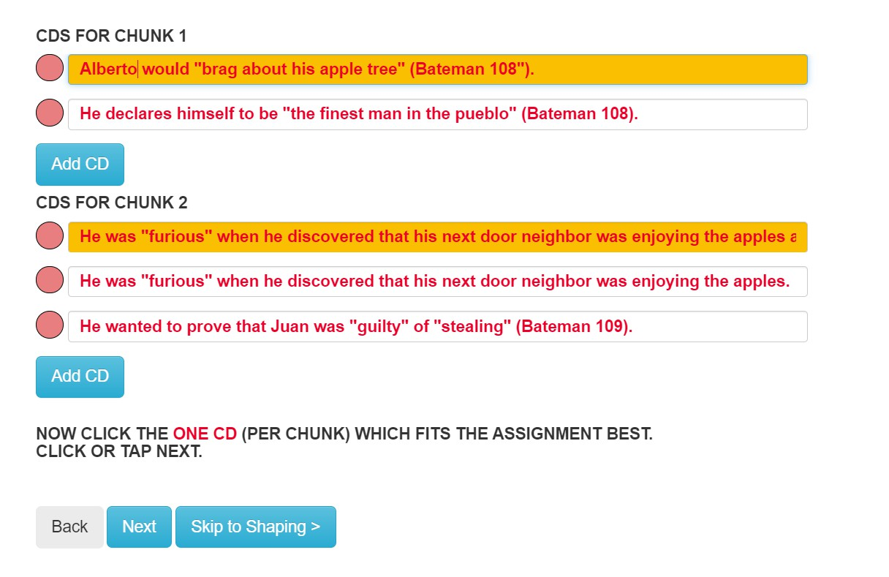

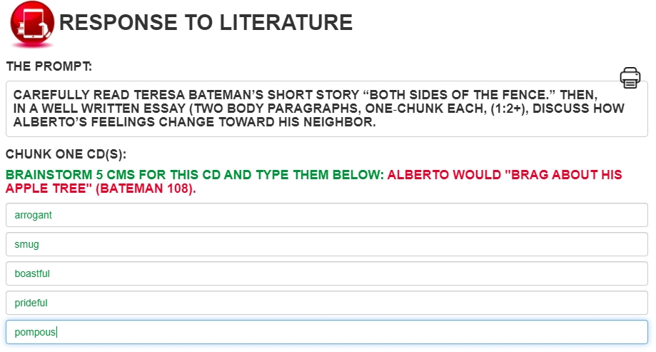
STEP TWO: GENERATING COMMENTARY
- REVIEW the
writing prompt.
- Brainstorm 5 CMs for the first CD.
- Brainstorm 5 CMs for the second CD.
- PRINT and/or CLICK <Next>.

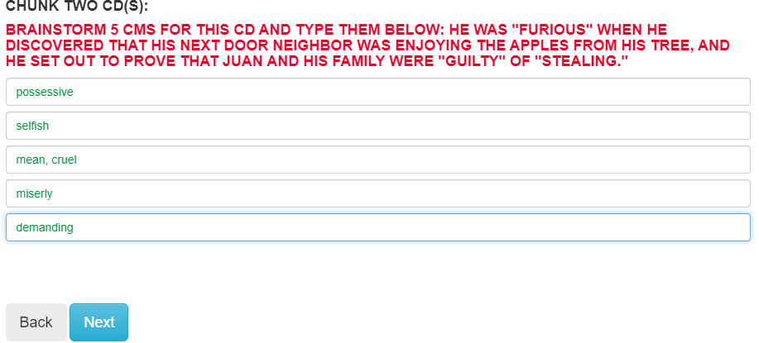


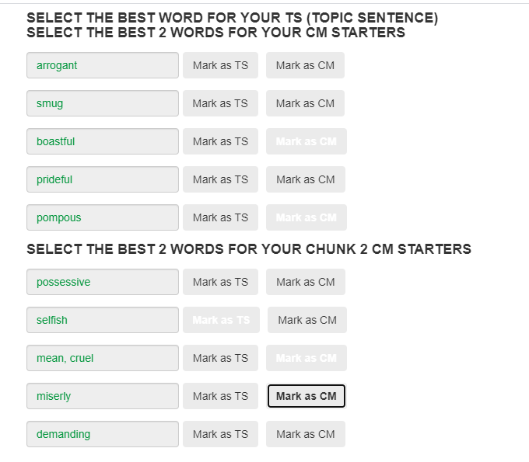
MAKING DECISIONS

  - Select the BEST word from the whole list for your TS.
  - Chunk 1:
Select the BEST two words for you CMs.
  - Chunk 2:
Select the BEST two words for you CM.

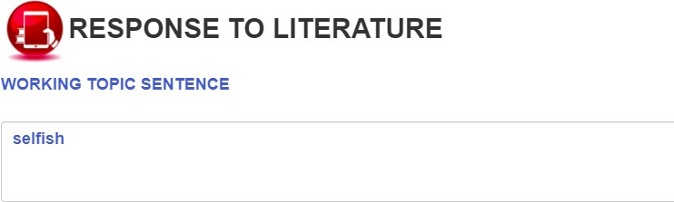
CREATE A WORKING TOPIC SENTENCE

- c
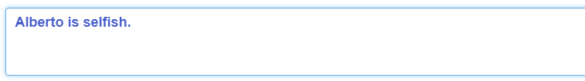
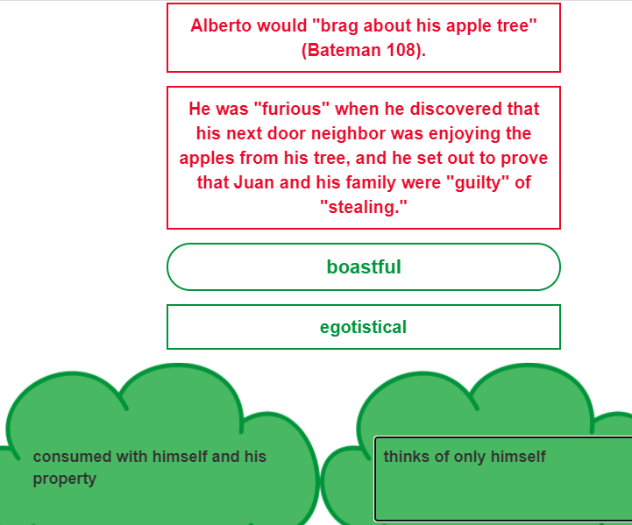
- Look at the first green CM (“boastful”); provide a synonym in the rectangular box.
- Provide two different phrases that explain more how these two words answers the prompt, expands the TS, and interprets the first CD.
- Look at the second CM (“pompous”); provide a synonym in the rectangular box.
- Repeat #4.

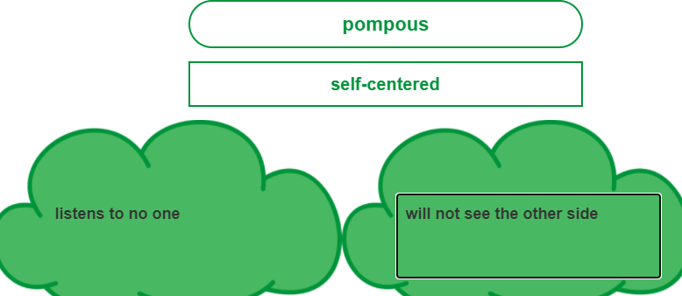

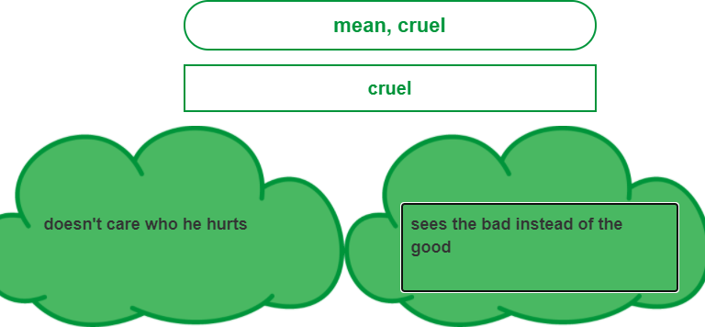
- Reread your second CD sentence.
- Look at the third green CM (“mean”); provide a synonym in the rectangular box.
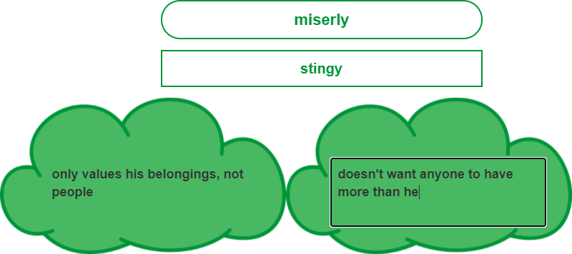
- Provide two different phrases that explain more how these two words answers the prompt, expands the TS, and interprets the first CD.
- Look at the fourth green CM (“miserly”); provide a synonym in the rectangular box.
- Repeat #9.

STEP THREE (CONT’D):

- REVIEW your CM
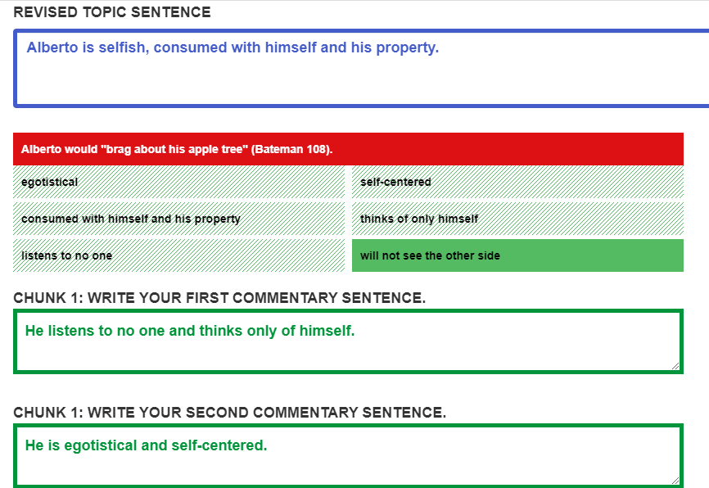
choices and ask yourself, “How do I want to revise my topic sentence (TS)”?
- HIGHLIGHT the words and phrases that you will use to revise your TS. Remember, “once you use it, you lose it!”
- REVIEW THE
REMAINING CM choices for the first CD and SELECT words and phrases to write your two commentary (CM) sentences.
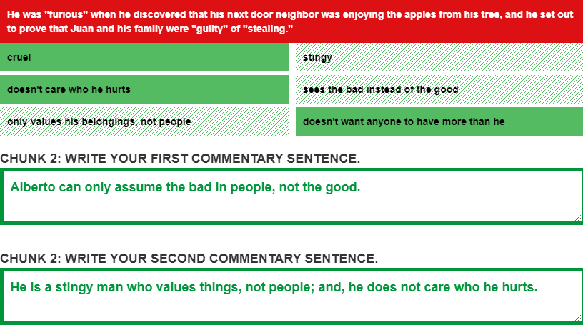

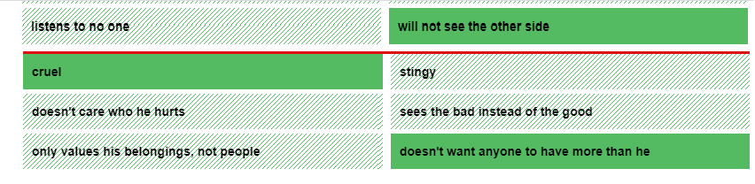
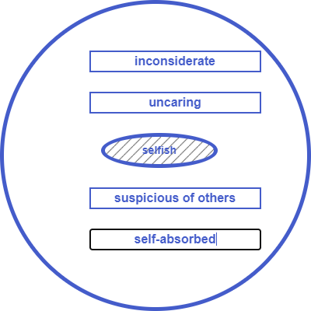
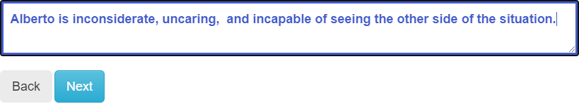

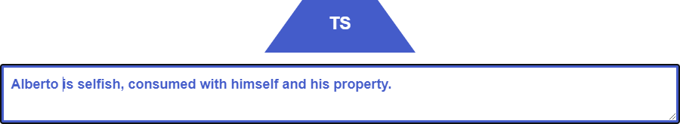
THE SHAPING SHEET

- Now it’s time to revise, edit, and proof our work. Let’s start by introducing the title of the work, the author’s name, and the main character. We also answer the prompt.

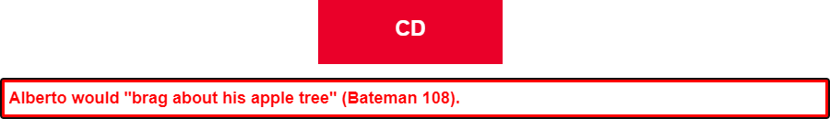
- For our CD, we situate the story at the beginning. Then, we decide that we want to add the part about Alberto declaring himself to be the “finest man in the pueblo.” This gives the reader more understanding about his nature.


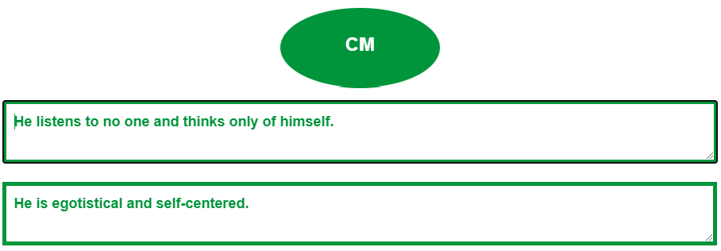
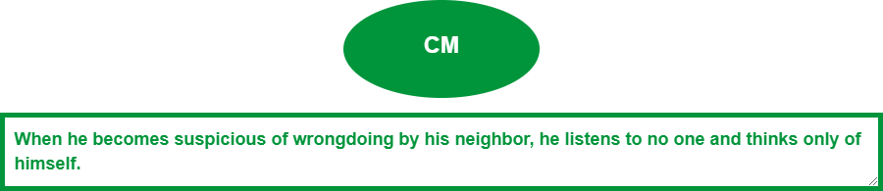
- For the first chunk’s CM sentences, we will revise them so as not to be repeating “[h]e in both sentences. To the right are the original sentences we created.

Here are the revised sentences.

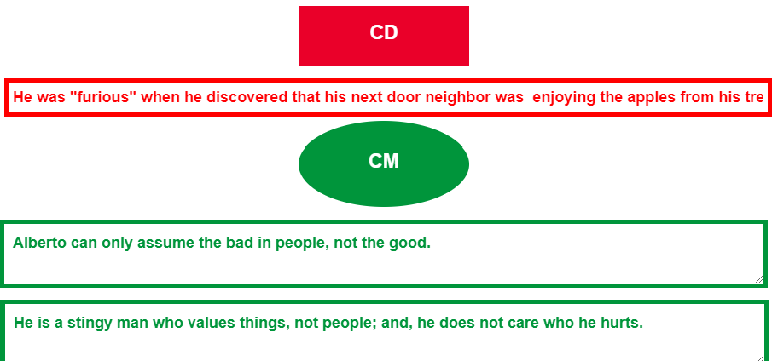
- For the second chunk, we need little revision.

I also noticed that the CD is in past tense instead of the literary present tense, so I will change it, too.

He becomes "furious" when he discovers that his next- door neighbor is enjoying the apples from his tree, and he sets out to prove that Juan and his family are "guilty" of "stealing" (Bateman 109).

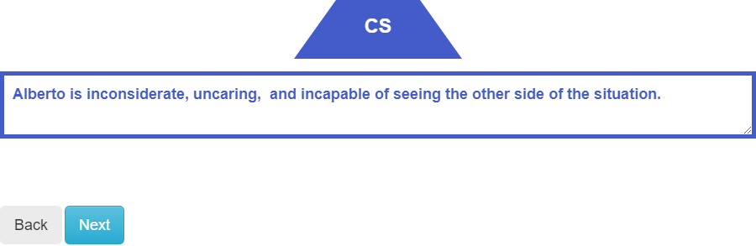
I added the parenthetical citation, as well, on the CD.

- Revising the CS is the final step in the revising and editing process.

I really like the repetition of the “k” sound in “inconsiderate,” “uncaring,” and “incapable.”

- Print and/or Click <Next.>


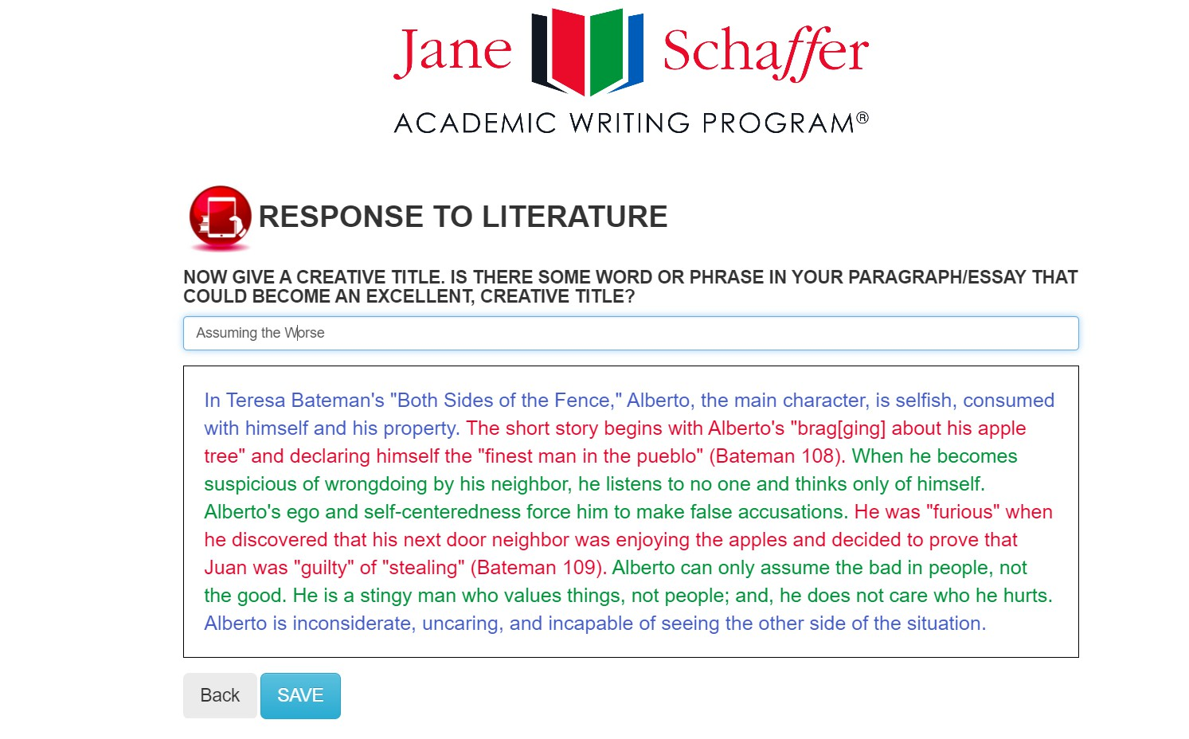

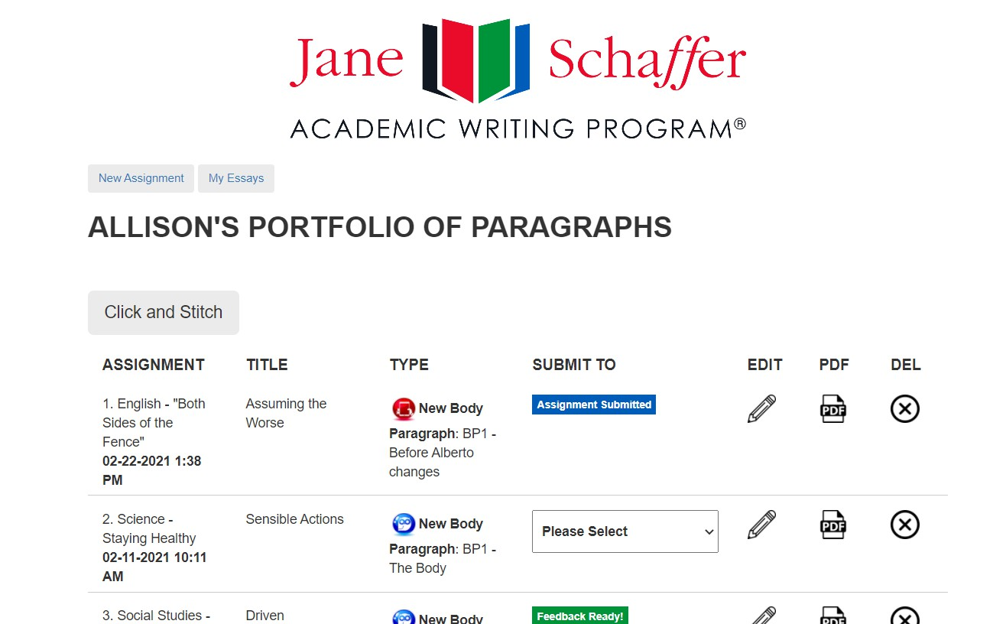
FINAL DRAFT AND
PORTFOLIO
- Our final draft is written. We need to add a Creative Title. I chose “Assuming the Worse,” because it reminds me of Alberto at the beginning of the story.
- CLICK <Save>.
- Now the Student has returned to her “Portfolio of Paragraphs.”
- She may submit her assignment to her teacher, edit, make it into a .pdf, or delete.
- Once she submits her paragraph or essay, the teacher will see its submission in the teacher portfolio.



EXPOSITORY


START AN ASSIGNMENT
1. Select the button
that says, “New Click Here Or Click
Assignment” or Here
Click <New>.
- Select the Mode of Discourse:
  - Expository
  - Argumentation
  - Literary
  - Narrative

THE EXPOSITORY PARAGRAPH


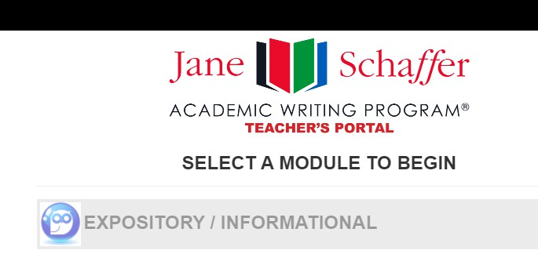


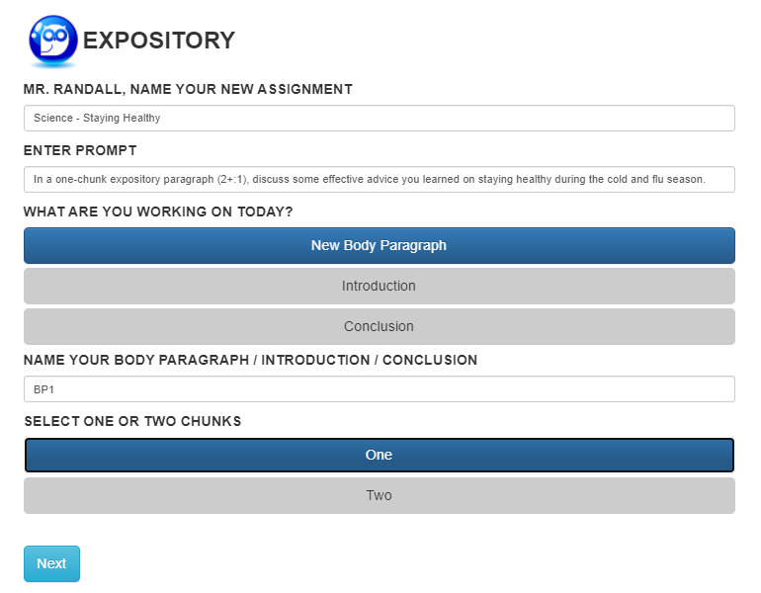
- Name Your Assignment (e.g., Science - Staying Healthy)
- Enter Prompt: In a one-chunk expository paragraph (2+:1), discuss some effective advice you learned on staying healthy during the cold and flu season.
- Select <New Body Paragraph>.
- Name Your Body Paragraph: BP1 or BP1 – The Body.
- Determine One or Two Chunks.
- Click <Next>.


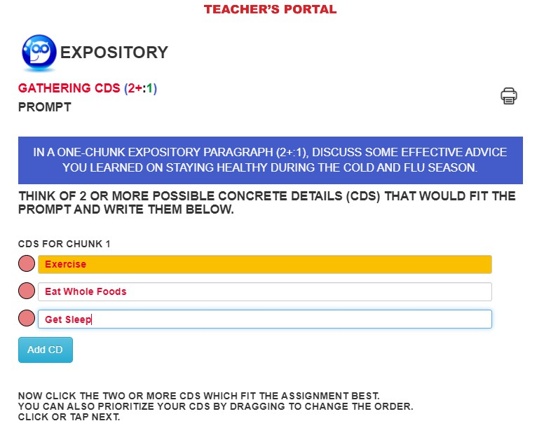

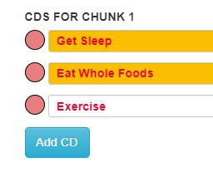
STEP ONE: GATHERING CDS
- LIST AND ADD 3-5
concrete details (CDs).
- HIGHLIGHT the 2+
CDs that you want to use.
- DRAG the red buttons to ORDER your CDs.
- PRINT and/or CLICK
<Next>.


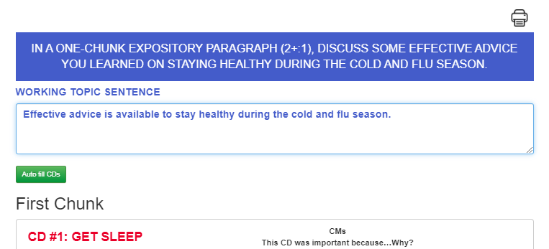

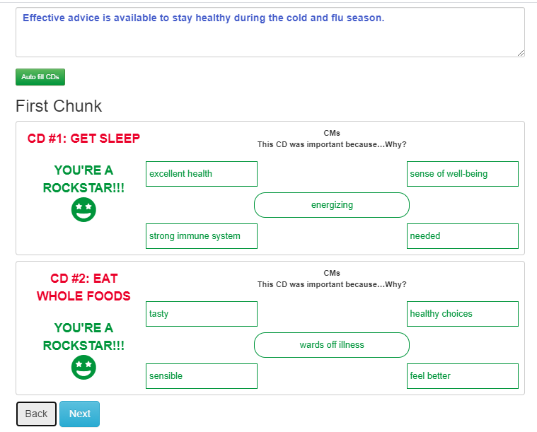
STEP TWO:
WORKING TOPIC SENTENCE
- REVIEW the writing prompt.
- TURN the prompt around to compose a “working topic sentence.”
- After you type several characters, you’ll notice that the CDs you selected on the previous page populate in the order you chose.
STEP THREE: THE T-CHART
- REVIEW your first CD.
- ASK YOURSELF, “Why is
this important?”
- BRAINSTORM your
ideas, starting with the middle oval.
- CONTINUE BRAINSTORMING. You
must provide at least three commentary (CM) ideas.
- REVIEW your second CD.
- FOLLOW STEPS #2-4
above to generate commentary ideas for your second CD.

CAUTION: THIS PAGE AND THE NEXT MUST BE COMPLETED. IF YOU THINK YOU DO NOT HAVE ENOUGH TIME, WAIT TO DO THESE PAGES OR WRITE DOWN WHAT YOU WROTE, SO YOU WON’T LOSE YOUR
WORK.


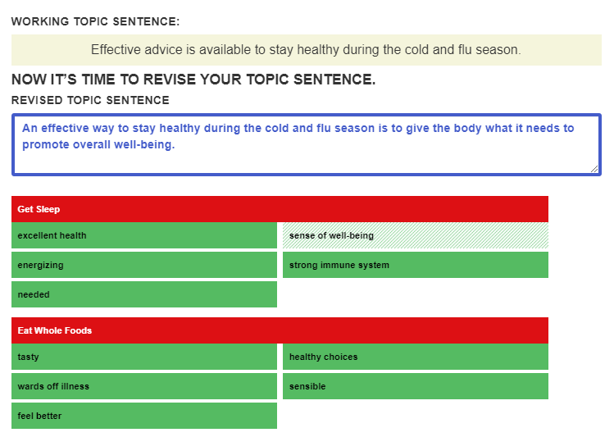

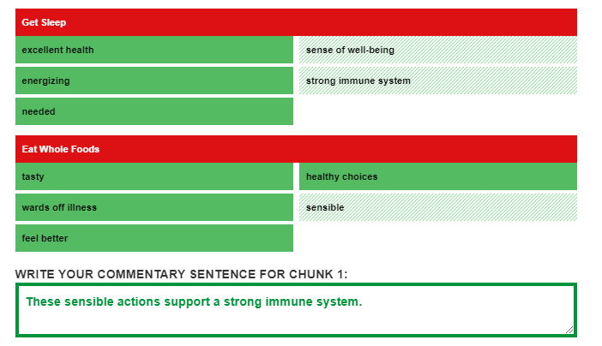

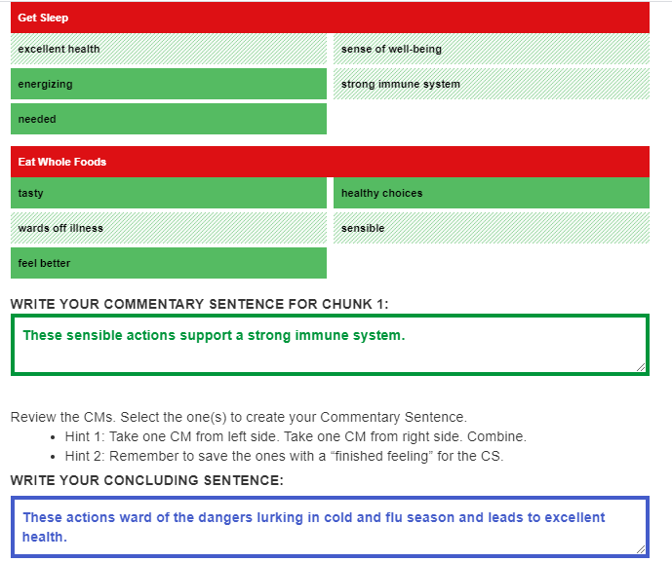
STEP THREE (CONT’D):
- REVIEW your CM
choices and ask yourself, “How do I want to revise my topic sentence (TS)”?
- HIGHLIGHT the words and phrases that you will use to revise your TS. Remember, “once you use it, you lose it!”
3. REVIEW THE
REMAINING CM choices and SELECT words and phrases to write your commentary (CM) sentence.
- REVIEW THE
REMAINING CM choices and SELECT words and phrases to write your concluding sentence (CS).
- CLICK <Next>.
(Notice the subject/verb agreement error – “leads” vs. “lead.” We did that on purpose to show you that we proof, edit, and revise
on our shaping sheet!)


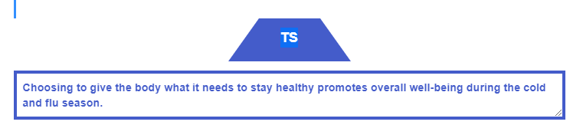

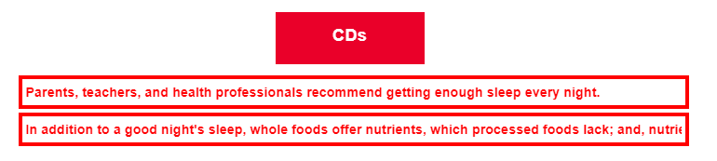

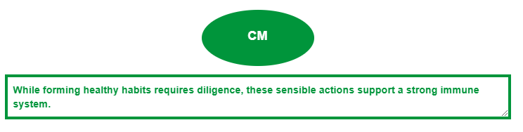

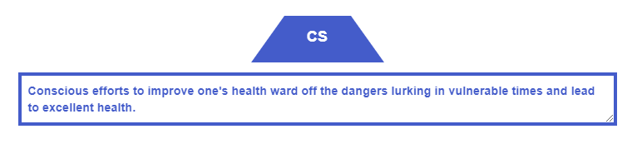

STEP FOUR:
THE SHAPING SHEET
PROOF, EDIT, AND REVISE
your topic sentence (TS). Our original TS had a “to be” verb. Action verbs give more information and have more of an impact. One way to rid your sentence of a “to be” verb is to invert the sentence.
We now need to write our concrete detail sentences. Use a transition when moving from the first CD to the second one. Here, we use “in addition.”
We liked our commentary sentence (CM), but we realized that in our original concluding sentence, we were repeating “these” and “actions;” so, we’re going to make some changes.
We revise our concluding sentence (CS) to avoid the repetitive words we mentioned above. Also, we fix the subject/verb agreement error from “leads” to “lead.”
CLICK <Next>.


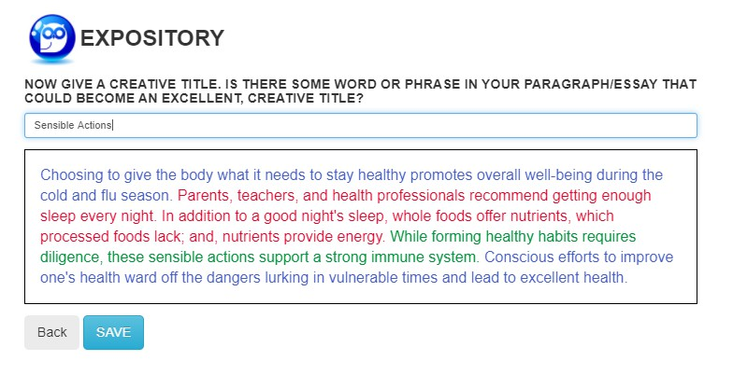
FINAL DRAFT AND PORTFOLIO
Our final draft is written. We need to add a Creative Title. Look inside your paragraph and see if there is a word or phrase you’d like to use for your title. I chose “Sensible Actions.” CLICK <Save>.
Now, you’re back to your portal.
- The Assignment that you just saved is there.
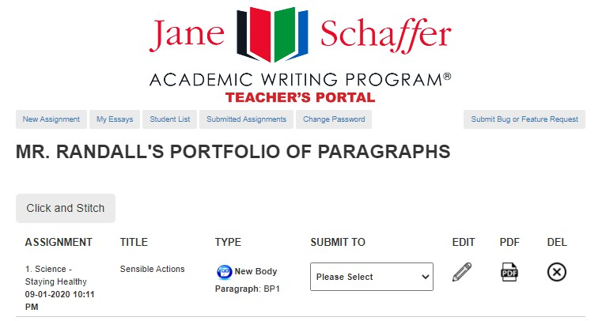

- Assignment Name
- Creative Title
- Type – Expository (Owl icon)
- Submit To = Here is where your students will submit their paragraphs to you.
- Edit – You can go into it again and make edits.
- PDF – create a PDF and print
- DEL = Delete

ARGUMENTATION

START AN ASSIGNMENT
1. Select the button

that says, “New Click Here Or Click
Assignment” or Here
Click <New>.



- Select the Mode of Discourse:
  - Expository
  - Argumentation
  - Literary
  - Narrative

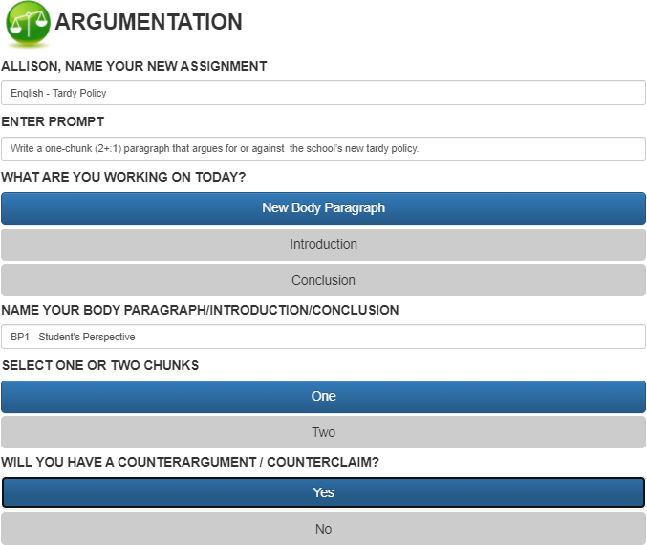

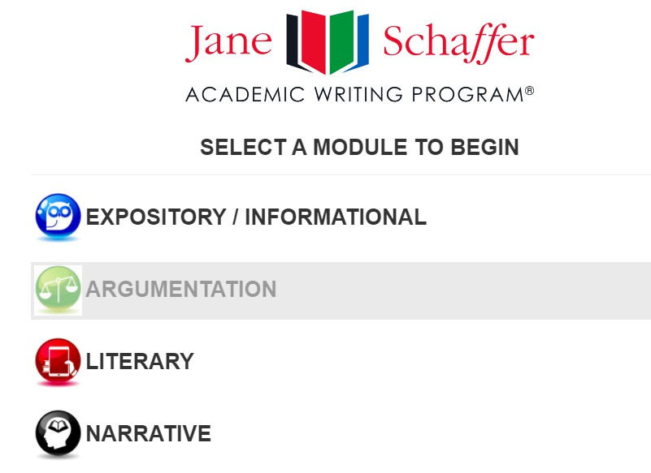
THE ARGUMENTATION PARAGRAPH
STUDENT PORTAL
- Name Your Assignment English – Tardy Policy
- Enter Prompt: Write a one-chunk (2+:1) paragraph that argues for or against the school’s new tardy policy.
- Select <New Body Paragraph>.
- Name Your Body Paragraph: BP1 or BP1 – Student’s Perspective.
- Determine One or Two Chunks. One Chunk.
- Click <Next>.

STEP ONE:
GATHERING CDS

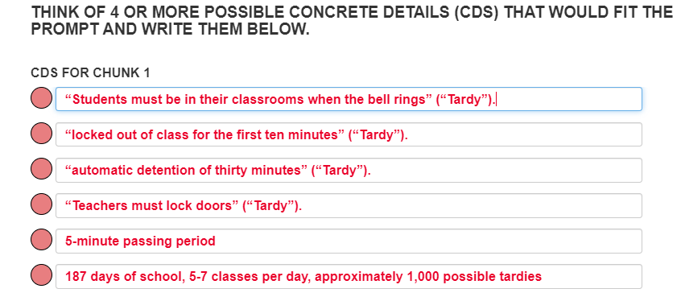
- LIST AND ADD 3-5
concrete details (CDs) for each chunk.


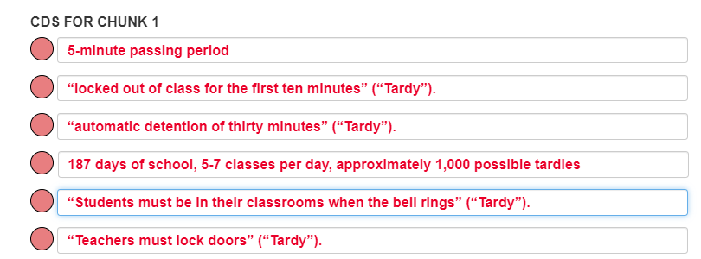
- Using the red dots, drag the CDs in the order you think best.


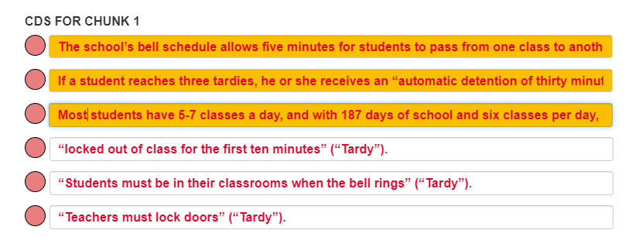
- COMBINE AND HIGHLIGHT the CDs
that you want to use for each chunk.

- PRINT and/or CLICK
<Next>.


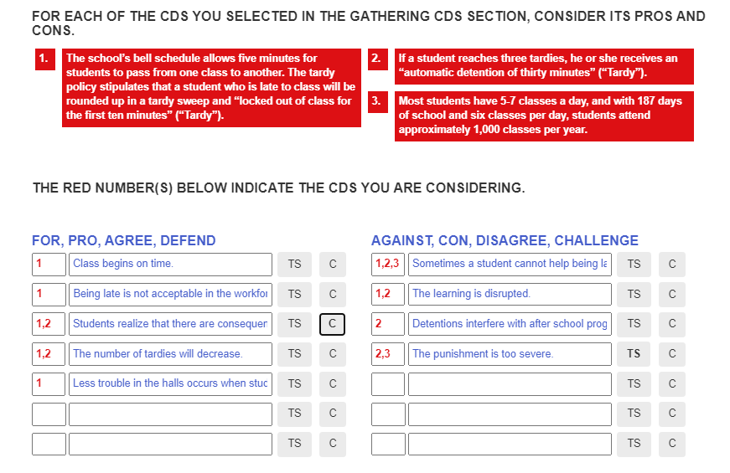
Topic Sentence Development
- For each of your CDs, ask the question, “What is positive about this CD?” Brainstorm as many positive attributes as possible for each CD and list them on the left side of the chart.
- Once you’ve exhausted that list, for each of your CDs, ask a new question, “What is negative about this CD?” Brainstorm as many negative attributes as possible for each CD and list them on the right side of the chart.
- Choose a side.
- On the side you choose, select the TS you are going to use.
- On the other side, choose the counterargument that works.


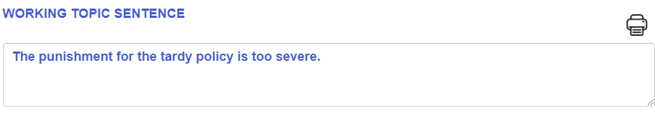
Working Topic Sentence

- Make a sentence out of your blue TS thought from the previous screen.
- Remember, it’s still a first draft.


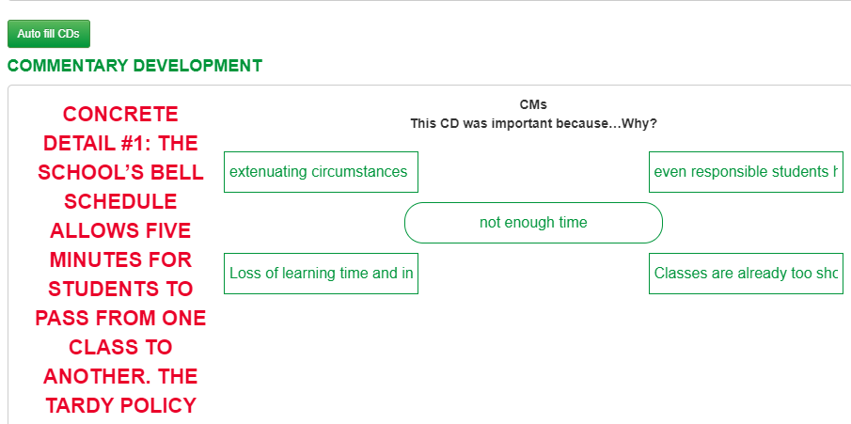

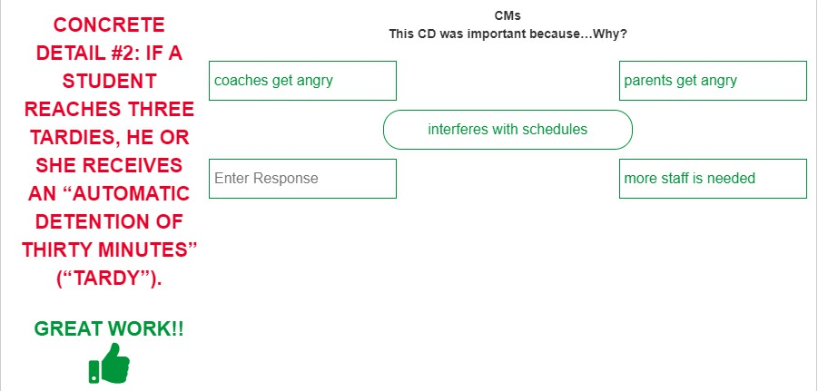

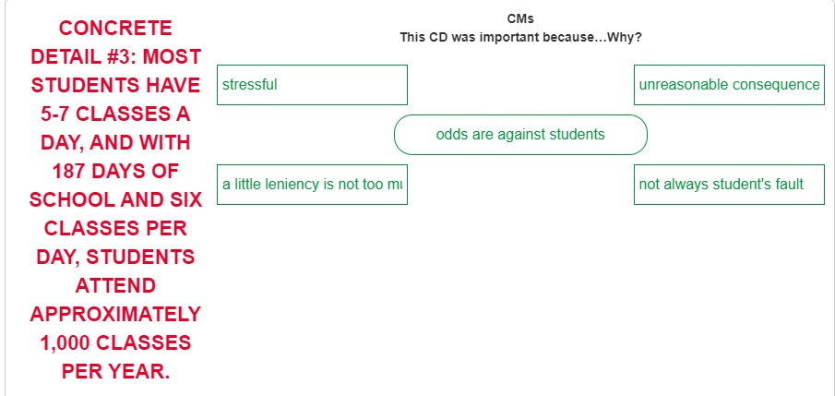
Generating Commentary

- Think about each of your CDs on the left. Ask yourself, “What is important about this particular CD that helps me to support my TS?”

- Brainstorm your thoughts and enter the CM boxes.
- For however many CDs you selected on the first page, you’ll be ask to generate commentary ideas.

- Insight: Sometimes one CD will generate a great amount of commentary; other times, it won’t. That’s why you might want to combine one or two on the first page.

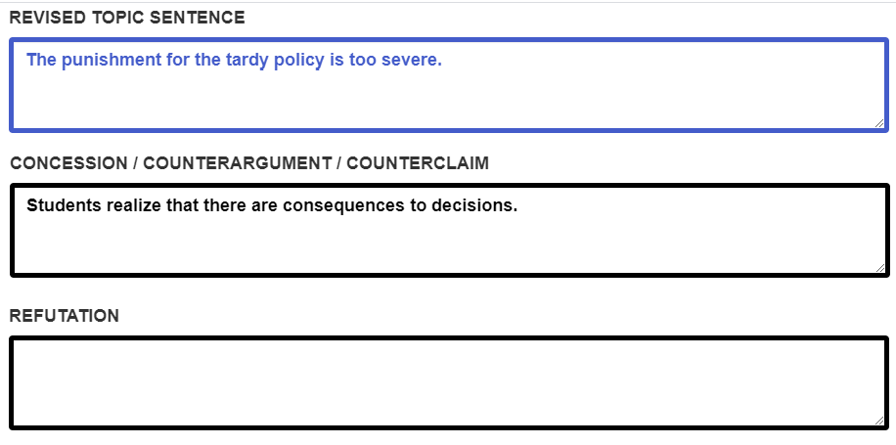
First Draft

- Using the green CMs that you brainstormed, you will
  - Revise your topic sentence;
  - Update your concession and counterargument;
  - Write your refutation;
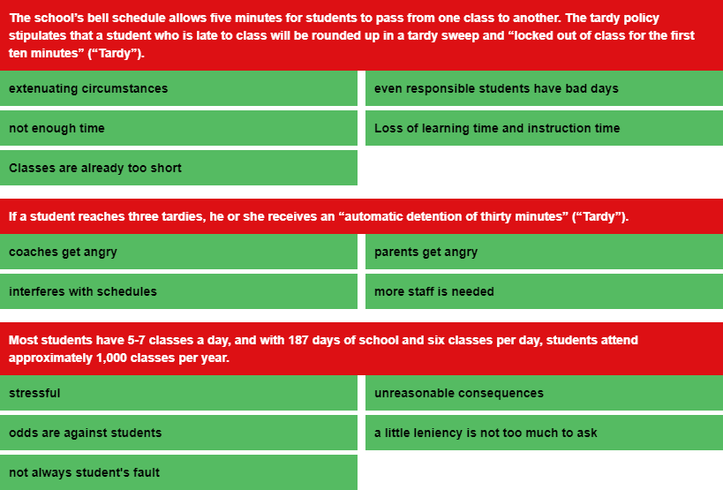
  - Write your commentary sentence; and
  - Write your concluding sentence.
- Remember, “when you use it, you lose it,” so click on the CMs you use, so you’ll not use them more than once.

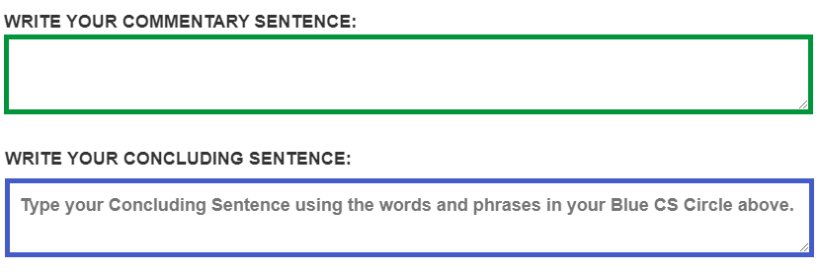

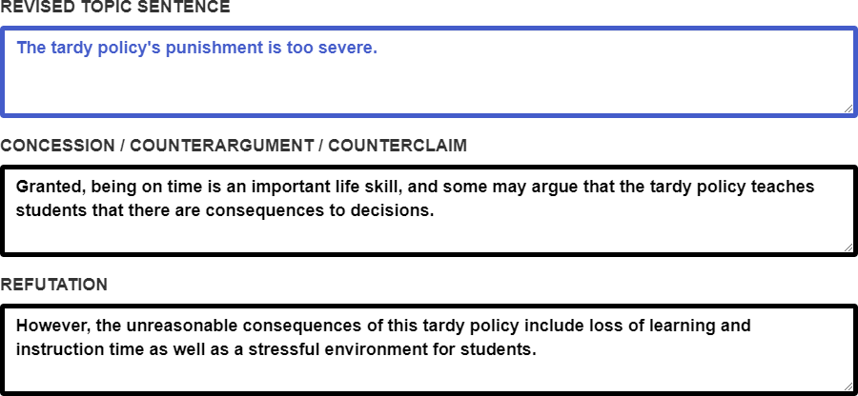
Here’s your first draft!

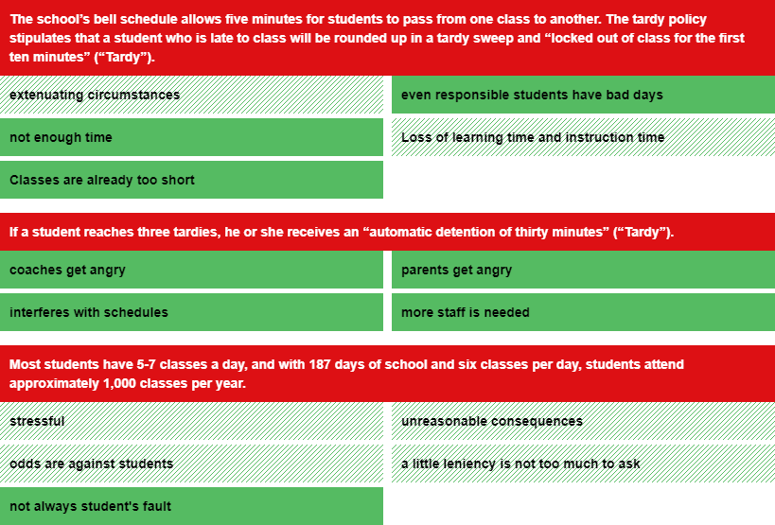
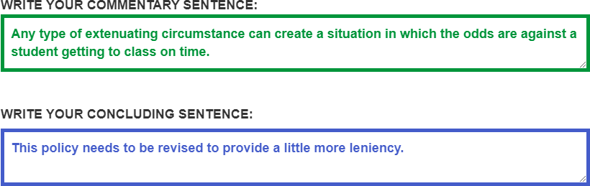

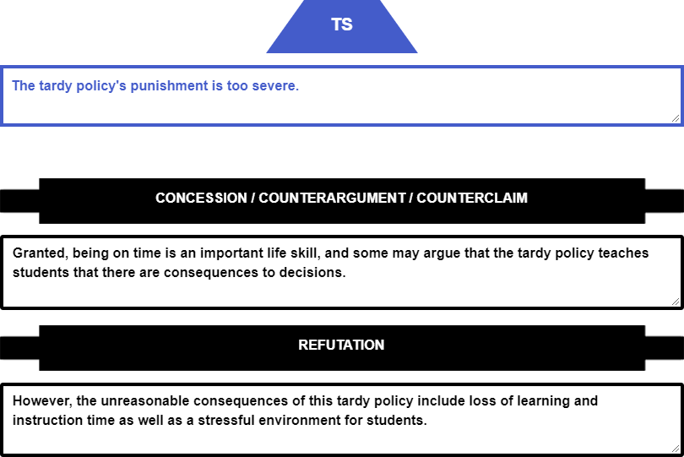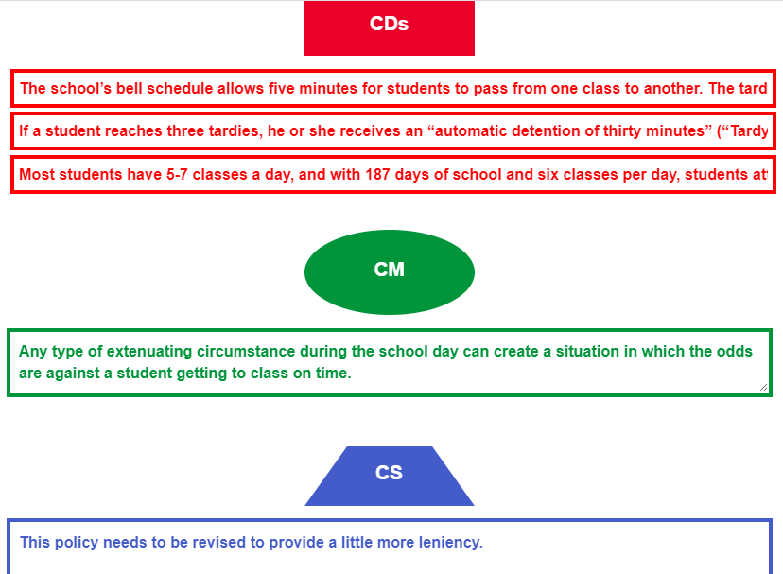

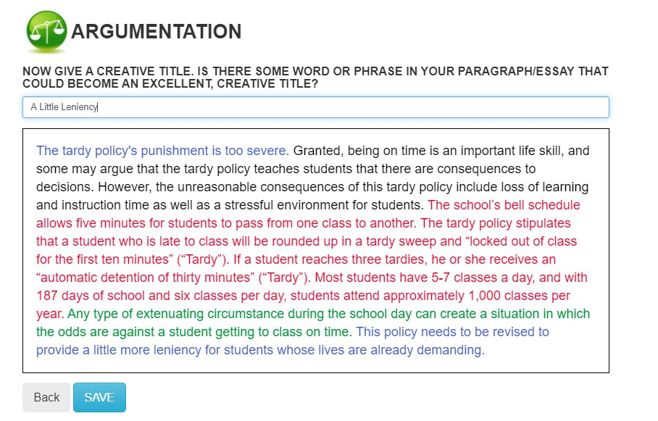

NARRATIVE

START AN ASSIGNMENT
1. Select the button

that says, “New Click Here Or Click
Assignment” or Here
Click <New>.



- Select the Mode of Discourse:
  - Expository
  - Argumentation
  - Literary
  - Narrative

THE NARRATIVE PARAGRAPH
STUDENT PORTAL
- Name Your

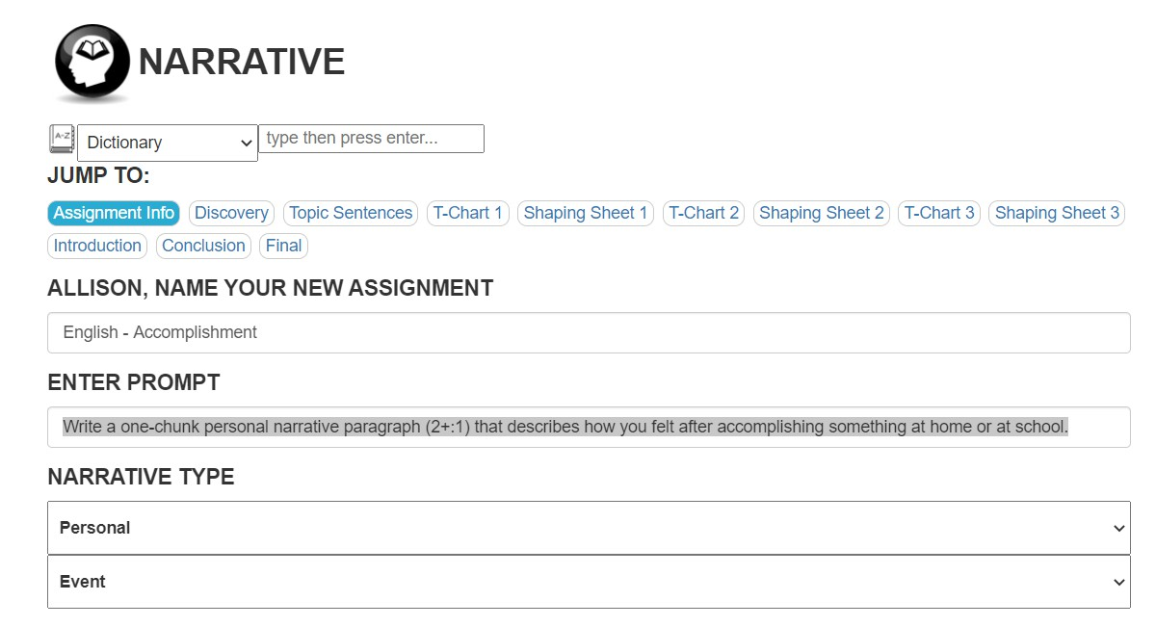
Assignment English – Accomplishment
- Enter Prompt: Write a one- chunk personal narrative paragraph (2+:1) that describes how you felt after accomplishing something at home or at school.
- Select <Personal>
- Select <Event>
- Click
<Save/Next>.

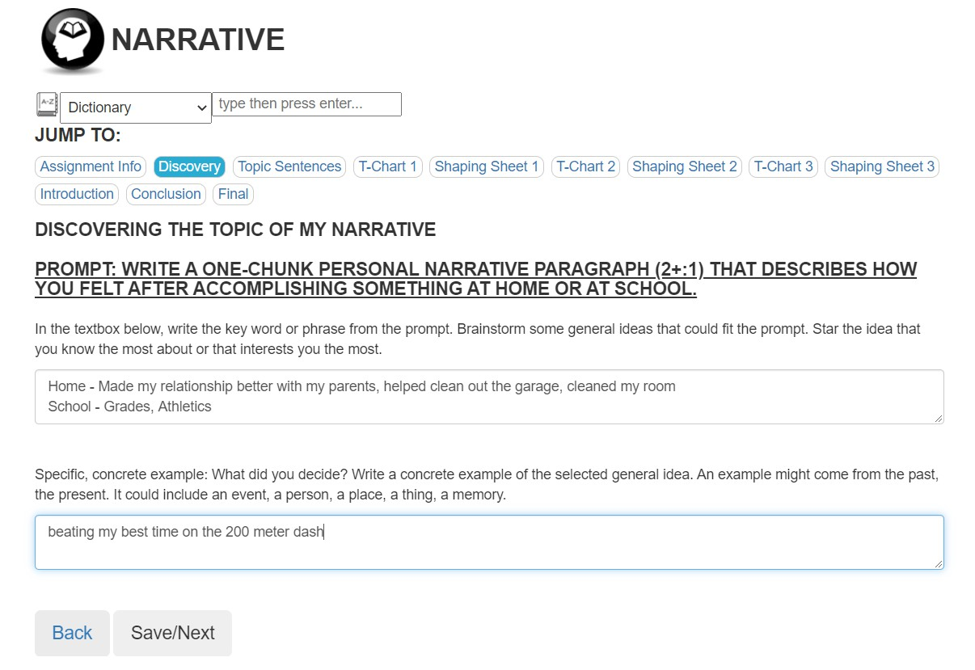

STEP ONE:  Discovering the Topic  - Rather than writing on the first idea that comes to your mind, LIST IDEAS pertaining to your topic.  - Consider  - Family  - Friends  - Employees  - Teachers  - Strangers    - At Home  - At School  - At Work  - At Play  - Consider  - When and Where in Life?  - Make a decision  - HIGHLIGHT the  one CD that you want to use for each chunk.  - Note: Dr. Louis combined the two CDs for the second chunk into one and chose that one!  - CLICK  <Save/Next>. |  |   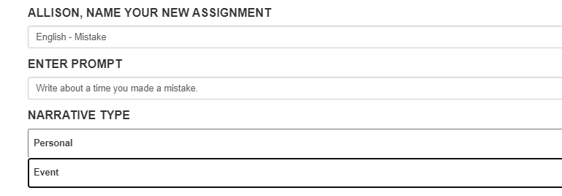  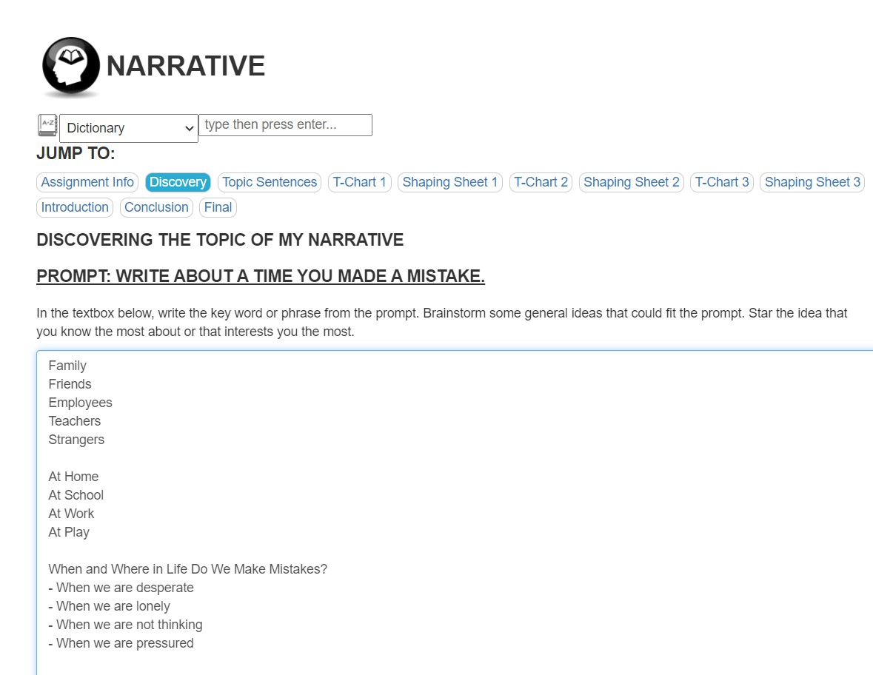  Let’s Look at Another Prompt Before Moving On


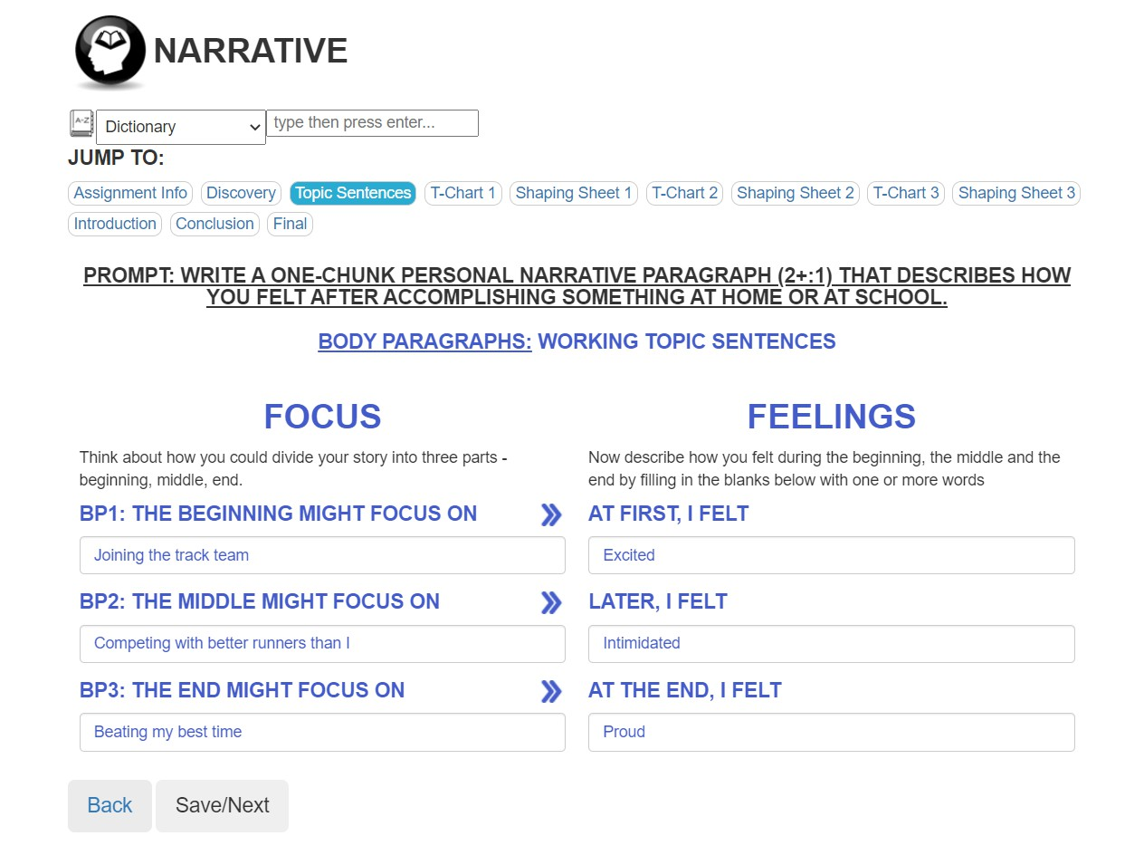



STEP TWO:
GENERATING COMMENTARY
- REVIEW the
writing prompt.
- Separate your event into three separate moments. Think of those moments in terms of how your attitude changed from the past to the present. Or from the present to the past and back to the present. Remember, this could be a simple moment in time.
- CLICK
<Save/Next>.
MAKING DECISIONS

- Select the BEST word from the whole list for your TS.
- Chunk 1:
Select the BEST two words for you CMs.
- Chunk 2:
Select the BEST two
words for you CM.

